Name: Thamburaj b
Roll No: 240701559
AIM:
The aim is to create data visualizations, such as pie charts and bar graphs, for an inventory management system using JavaScript.
PROCEDURE:
Step 1:
Set Up Your HTML File
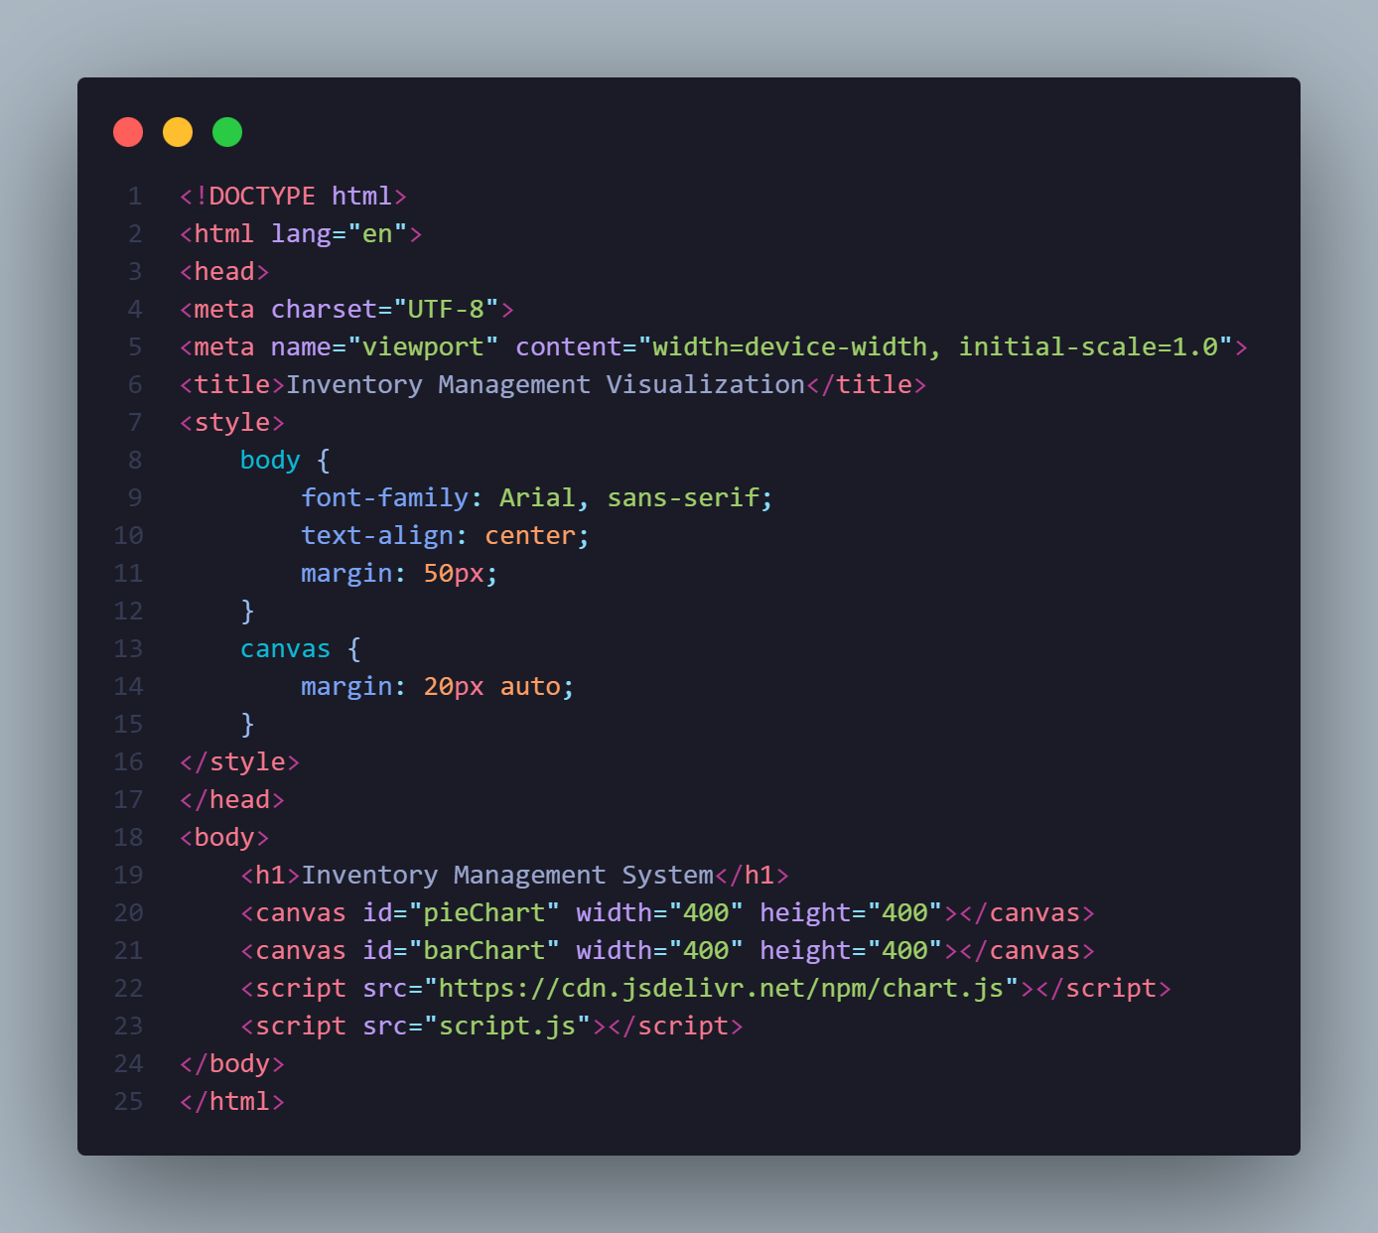

Step 2:
Create the JavaScript File for Charts Next, create a JavaScript file (script.js) to handle the data visualization logic.

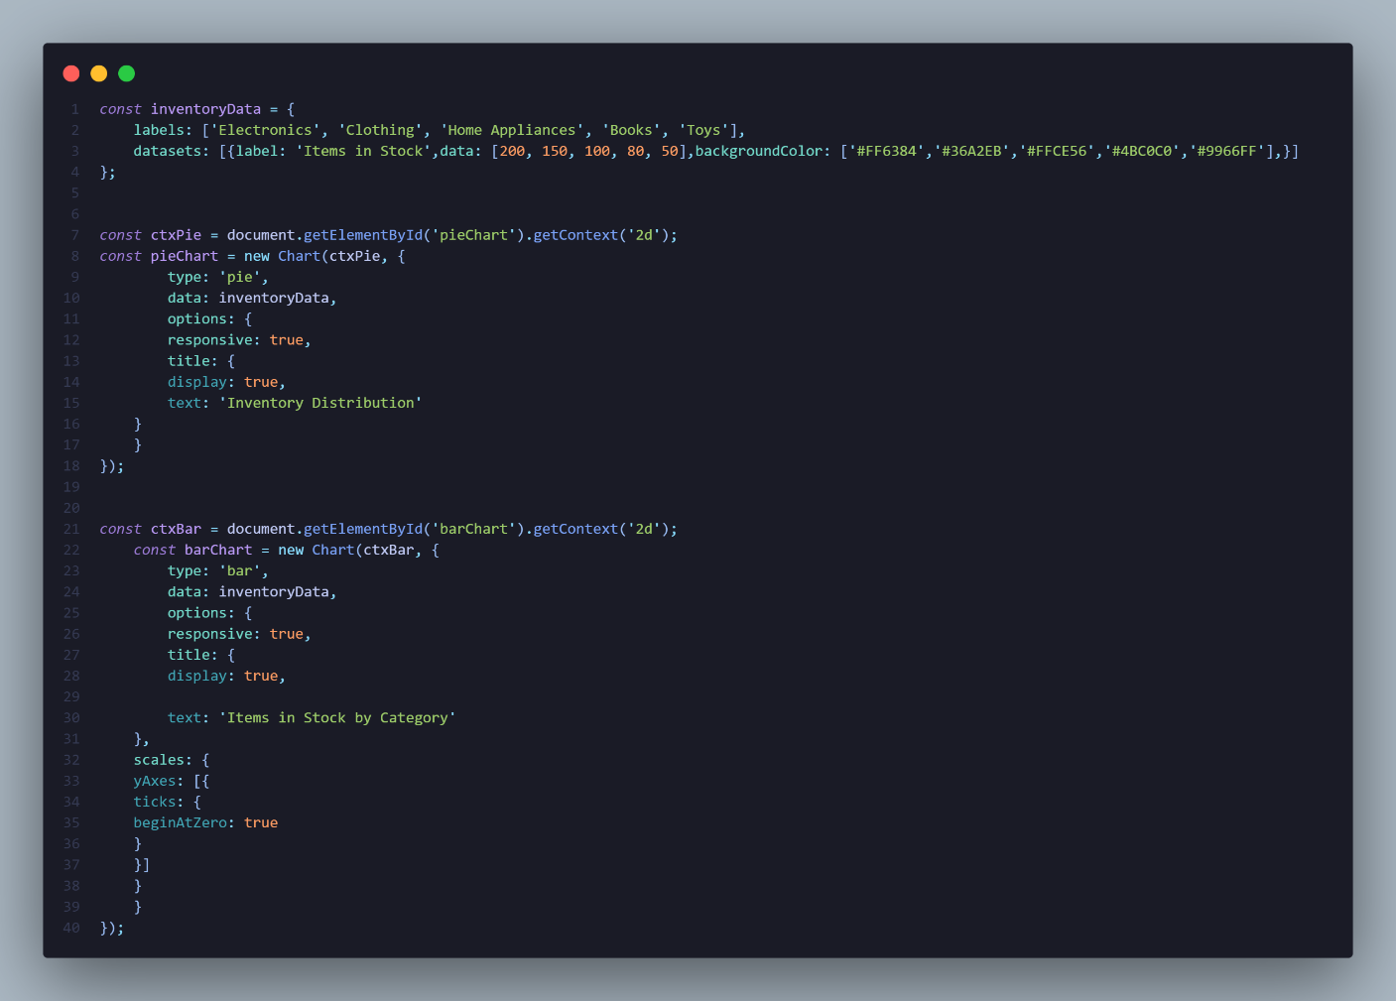
OUTPUT:
